Epsom & Ewell
20
v
British Airways
Saturday, 16th February 2019 – 3.00 p.m.
Good afternoon and welcome to the players, supporters and officials of British Airways who are making their first visit to us, and looking for a League double following their 3-2 win over us at the Orchard back in October.

That match was of course the last in charge for our former Manager Neil Grant and it’s fair to say that things have improved immeasurably since then. We go into this match on the back of just one defeat in our last eighteen matches, the last ten of which have been unbeaten and remain in three cup competitions with an exciting end to the season in prospect should we keep this form up. Today’s opponents lie in midtable and will prove a difficult prospect, but they were beaten 4-1 by Bedfont & Feltham recently and it is the performances of clubs like those that we have to match, or there will be no shot at promotion anyway!

I wonder if the history can help us here. When we last met on 10th October we hadn’t won on that particular date since 1964 and duly lost. Today is the best day of the entire year for us with eleven wins and three draws from our 15 matches on this date. However, we have only won one of the last three matches we have played so will have to be careful if that record is not to be dented!

We were last at High Road just four days ago on Tuesday when we met Godalming Town for the third time this season; this time in a League Cup tie, and the result in our favour was more decisive as we won 5-1 with a fine display. We visit Abbey Rangers in the Quarter-Final on a date to be advised. Please note that the match will almost certainly be on a Monday evening.

We now face a run of away matches and blank Saturdays before returning here in almost a month’s time on Tuesday 12th March to face FC Deportivo Galicia in a League match. We visit Imber Court on Wednesday in the Quarter-Final of the Surrey Premier Cup where we will meet the Met Police Academy side. Then on Saturday we visit Frimley Green for an extremely important league match on a ground where we have an excellent record with five wins from five, four of them heavy victories. We then have a Saturday off on 2nd March and seven days later we then travel to Leatherhead FC, the temporary home of Kensington Borough, who we meet in a League match.

We thank our double match sponsors today, Steve Charnley and Pete Lumm. We have many players and a couple of matches left for sponsorship, so don’t be shy, just speak with a Committee member for details. You know who and where we are!

Enjoy the game!

Rich
You can follow us on Facebook: www.facebook.com/epsomandewellfc
Twitter: @EEFCOfficial Instagram at: www.instagram.com/epsomandewellfc
and Youtube at: www.youtube.com/channel/UCtLrpS0x5OaYUACRT34_zng

Cover photos by Gemma Jarman

- Rob Hendry scores our opening goal in the 3-1 victory at Godalming Town on 26th January
- Billy Carney scores our second goal in the same match
- Bobby Bennett sees his penalty saved at home to Bagshot, but will net the rebound

Cherry Red Records Combined Counties League
Division One Table 2018/19
inc Tuesday 12th February 2019 | P | W | D | L | F | A | Pts | GD | H | A

Bedfont & Feltham | 23 | 16 | 5 | 2 | 78 | 26 | 53 | +52 | 4-4 | 13/4
Frimley Green | 24 | 16 | 5 | 3 | 48 | 27 | 53 | +21 | 3-0 | 23/2
Sheerwater | 24 | 16 | 4 | 4 | 63 | 32 | 52 | +31 | 2-3 | 19/3
Epsom & Ewell | 24 | 15 | 3 | 6 | 61 | 37 | 48 | +24 | X | X
Farnham Town | 22 | 13 | 4 | 5 | 47 | 23 | 43 | +24 | 27/4 | 1-4
Tooting Bec | 22 | 12 | 5 | 5 | 51 | 28 | 41 | +23 | 3-1 | 30/3
Ash United | 25 | 12 | 5 | 8 | 64 | 52 | 41 | +12 | 1-1 | 2-1
Dorking Wanderers Res | 27 | 11 | 4 | 12 | 55 | 60 | 37 | -5 | 3-0 | 3-5
Sandhurst Town | 21 | 11 | 3 | 7 | 33 | 35 | 36 | -2 | 20/4 | 2-0
Chessington & Hook Utd | 23 | 9 | 5 | 9 | 44 | 44 | 32 | 0 | 1-2 | 4-1
British Airways | 24 | 9 | 4 | 11 | 50 | 59 | 31 | -9 | 16/2 | 2-3
Bagshot | 27 | 8 | 4 | 15 | 35 | 78 | 28 | -43 | 7-1 | 3-0
Godalming Town | 24 | 8 | 3 | 13 | 37 | 56 | 27 | -19 | 3-2 | 3-1
FC Deportivo Galicia | 23 | 6 | 3 | 14 | 39 | 45 | 21 | -6 | 12/3 | 3-0
Eversley & California | 22 | 5 | 2 | 15 | 39 | 55 | 17 | -16 | 1-0 | 1-2
Cove | 24 | 4 | 3 | 17 | 30 | 53 | 15 | -23 | 3-2 | 2-1
Fleet Spurs | 24 | 5 | 0 | 19 | 41 | 73 | 15 | -32 | 6/4 | 3-2
Kensington Borough | 23 | 3 | 6 | 14 | 27 | 59 | 15 | -32 | 1-1 | 9/3

AC London (removed) | 15 | 9 | 2 | 4 | 36 | 25 | 29 | +11 | - | 6-0

Lucky Day? – 16th February
Played 15 - Won 11 Drawn 3 Lost 1 - For 48 Against 15 - PPG 2.40 – Fantastic
The 16th February is currently our best day of the year for results!
Our Club record against British Airways
Played 1 - Won 0 Drawn 0 Lost 1 - For 2 Against 3 - PPG 0.00
Our Largest wins and losses against British Airways
No wins
10th October 2018 - L 2-3 - Combined Counties League (A)
British Airways’ Last Visit
This is their first visit

First Eleven Appearances 2018/19 - (max 35)
Name | Debut | 2018/19 |  |  |  | Career Totals
 |  | App | Sub | Tot | Goals | App | Sub | Tot | Goals
BENNETT Bobby | 12/08/2018 | 29 | 0 | 29 | 19 | 29 | 0 | 29 | 19
BETANCOURT Steve* | 18/08/2018 | 21 | 1 | 22 | 1 | 21 | 1 | 22 | 1
BORRETT Ricky* | 04/08/2018 | 9 | 0 | 9 | 0 | 9 | 0 | 9 | 0
CAMPBELL Kieran* | 29/09/2012 | 7 | 3 | 10 | 2 | 59 | 3 | 62 | 2
CAMPBELL Theo* | 28/08/2018 | 2 | 9 | 11 | 1 | 2 | 9 | 11 | 1
CARNEY Billy | 12/01/2019 | 4 | 1 | 5 | 5 | 4 | 1 | 5 | 5
CAULCRICK Joshua | 17/02/2018 | 0 | 4 | 4 | 0 | 0 | 5 | 5 | 0
CHICK Ben | 29/12/2018 | 3 | 4 | 7 | 2 | 3 | 4 | 7 | 2
CHIN Louis | 08/12/2018 | 6 | 0 | 6 | 0 | 6 | 0 | 6 | 0
CONNELLY Lloyd | 14/10/2017 | 34 | 0 | 34 | 4 | 64 | 4 | 68 | 6
DOBRAJ Endrit* | 18/11/2017 | 5 | 2 | 7 | 1 | 24 | 6 | 30 | 1
DYSON Ben* | 12/08/2017 | 0 | 1 | 1 | 0 | 28 | 14 | 42 | 2
ELGAR Luke | 04/08/2018 | 13 | 3 | 16 | 2 | 13 | 3 | 16 | 2
ELGAR Scott* | 12/08/2018 | 4 | 9 | 13 | 0 | 4 | 9 | 13 | 0
GAFFNEY Luke * | 16/08/2014 | 2 | 2 | 4 | 0 | 12 | 3 | 15 | 0
GAYLE Roy | 06/11/2018 | 3 | 3 | 6 | 0 | 3 | 3 | 6 | 0
GILL George* | 28/08/2018 | 2 | 0 | 2 | 0 | 2 | 0 | 2 | 0
GRIFFIN Reisse | 08/08/2015 | 20 | 0 | 20 | 4 | 124 | 13 | 137 | 12
GRIFFITHS Hakim | 08/12/2018 | 2 | 3 | 5 | 2 | 2 | 3 | 5 | 2
HEAGNEY Adam | 16/08/2016 | 34 | 0 | 34 | 1 | 101 | 13 | 114 | 3
HENDRY Rob | 08/08/2015 | 19 | 0 | 19 | 15 | 103 | 23 | 126 | 43
JEANNOEL Germaine | 02/12/2017 | 1 | 10 | 11 | 2 | 3 | 17 | 20 | 3
JONES David* | 31/08/2018 | 6 | 2 | 8 | 0 | 6 | 2 | 8 | 0
LOFTUS-CHEEK Joe* | 06/08/2017 | 0 | 1 | 1 | 0 | 14 | 8 | 22 | 6
MARTINEZ Olly | 29/09/2018 | 8 | 4 | 12 | 2 | 8 | 4 | 12 | 2
MCKAY Alex | 20/12/2008 | 1 | 0 | 1 | 0 | 163 | 39 | 202 | 13
MORGAN Sam | 11/09/2018 | 2 | 6 | 8 | 0 | 2 | 6 | 8 | 0
MURPHY Scott | 20/01/2007 | 30 | 0 | 30 | 4 | 77 | 2 | 79 | 8
MURPHY Todd | 27/11/2018 | 1 | 4 | 5 | 0 | 1 | 4 | 5 | 0
ROBERTS Liam | 12/08/2017 | 23 | 2 | 25 | 11 | 44 | 16 | 60 | 16
SMITH Taryn | 28/10/2017 | 6 | 6 | 12 | 5 | 14 | 10 | 24 | 5
SULLIVAN Ryan | 04/08/2018 | 23 | 1 | 24 | 0 | 23 | 1 | 24 | 0
SUTHERLAND Mitchel* | 04/08/2018 | 1 | 1 | 2 | 0 | 1 | 1 | 2 | 0
THOMPSON Elliott | 09/02/2016 | 22 | 4 | 26 | 1 | 32 | 13 | 45 | 2
WATTS Jamie | 03/11/2018 | 6 | 1 | 7 | 1 | 6 | 1 | 7 | 1
WHITE Sean* | 02/08/2014 | 9 | 4 | 13 | 4 | 29 | 25 | 54 | 9
WOODCOCK Josh* | 22/09/2018 | 1 | 0 | 1 | 0 | 1 | 0 | 1 | 0
WRIGHT Kieran* | 15/09/2018 | 3 | 3 | 6 | 0 | 3 | 3 | 6 | 0
YOUNG Conor | 07/03/2015 | 23 | 0 | 23 | 0 | 56 | 0 | 56 | 0
* - Player has left the club

Recent Results and Fixtures
Combined Counties League Cup Third Round – Tuesday 12th February 2019
Epsom & Ewell | 5-1 | Godalming Town
Combined Counties League – Tuesday 12th February 2019
Chessington & Hook United | 4-1 | Farnham Town
Surrey Premier Cup QF – Saturday 16th February 2019
Nottsborough | V | Sheerwater
Combined Counties League – Saturday 16th February 2019
Bedfont & Feltham | V | Tooting Bec
Dorking Wanderers Reserves | V | Cove
Epsom & Ewell | V | British Airways
Eversley & California | V | FC Deportivo Galicia
Frimley Green | V | Godalming Town
Kensington Borough | V | Ash United
Sandhurst Town | V | Chessington & Hook United
Combined Counties League Cup QF – Tuesday 19th February 2019
CB Hounslow United | V | Banstead Athletic
Knaphill | V | Bedfont & Feltham
Combined Counties League – Tuesday 19th February 2019
Fleet Spurs | V | Chessington & Hook United
Surrey Premier Cup QF – Wednesday 20th February 2019
Met Police Academy U23s | V | Epsom & Ewell
Combined Counties League – Wednesday 20th February 2019
FC Deportivo Galicia | V | Sheerwater
Combined Counties League – Saturday 23rd February 2019
Bagshot | V | FC Deportivo Galicia
British Airways | V | Sandhurst Town
Chessington & Hook United | V | Bedfont & Feltham
Fleet Spurs | V | Kensington Borough
Frimley Green | V | Epsom & Ewell
Godalming Town | V | Cove
Sheerwater | V | Dorking Wanderers Reserves
Tooting Bec | V | Farnham Town
Combined Counties League – Tuesday 26th February 2019
Cove | V | Farnham Town
Eversley & California | V | Fleet Spurs
Combined Counties League – Wednesday 27th February 2019
Kensington Borough | V | Godalming Town
Recent Results and Fixtures
Combined Counties League – Saturday 2nd March 2019
Ash United | V | Fleet Spurs
Bedfont & Feltham | V | Godalming Town
Cove | V | British Airways
FC Deportivo Galicia | V | Farnham Town
Sandhurst Town | V | Frimley Green
Sheerwater | V | Eversley & California
Tooting Bec | V | Bagshot
Esoteric Division One Cup – Tuesday 5th March 2019
Tooting Bec | V | Frimley Green
Combined Counties League – Tuesday 5th March 2019
Eversley & California | V | Bagshot
Combined Counties League – Saturday 9th March 2019
British Airways | V | Ash United
Chessington & Hook United | V | Cove
Dorking Wanderers Reserves | V | Sandhurst Town
Farnham Town | V | Eversley & California
Fleet Spurs | V | Tooting Bec
Frimley Green | V | Bedfont & Feltham
Godalming Town | V | Sheerwater
Kensington Borough | V | Epsom & Ewell
Combined Counties League – Tuesday 12th March 2019
Bagshot | V | Sandhurst Town
Epsom & Ewell | V | FC Deportivo Galicia
Kensington Borough | V | Eversley & California

Ten Unbeaten
Our 5-1 win over Godalming Town on Tuesday extended our unbeaten run of matches to ten, something that has occurred sixteen times previously, which might sound a lot, but actually, over 100 years is not that often!

The last time we did this was in 2016/17 when we also went ten matches unbeaten before losing to Champions elect Hartley Wintney on 18th March 2017.

If we were to extend this to eleven, it would only be the eighth time we have reached that mark, which we last reached on 28th December 2015 at Horley Town before losing at home to Ashford Town (Mx) in the Combined Counties League Cup on 4th Jan 2016.

The record run is a surprisingly achievable 14 matches unbeaten, set in 1937 with an Amateur Cup replay win over Banstead Hospital on 9th October 1937, before the run was ended by Sutton United in the FA Cup seven days later. Then in 1927/28 we went ten matches unbeaten, losing against Summerstown in the Surrey Senior Cup before then producing another ten match unbeaten run!

Our record for consecutive League wins is 13, set in 2012/13 and for consecutive wins in all competitions it is ten, set at the same time, and also in 1926/27. We currently have four straight wins in all competitions and last time we exceeded that was of course, earlier this season with five. Six wins in all competitions last came in 2016/17. For more questions and answers, just visit the website and select the Ask The Historian page!

From behind the goal
Epsom & Ewell 5-1 Godalming Town
Combined Counties League Cup – Third Round - Tuesday 12th February 2019

Five star Salts earn trip to the Abbey

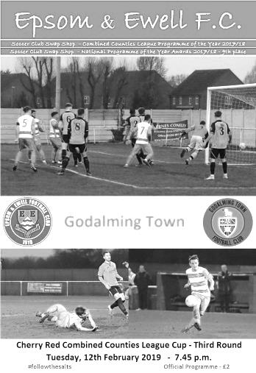
An impressive performance by our boys at High Road enabled us to produce a scoreline that was thoroughly deserved and on another day could have been heavier against a dispirited and outfought Godalming Town side that were probably fed up with seeing us after three wins over them in just ten weeks. We now face a tough challenge in the Quarter Final against Abbey Rangers at Addlestone Moor in a few weeks.

We made just one change to the line up from last week with Ben Chick coming in for Hakim Griffiths who was on the bench, while the ineligible Louis Chin and Jamie Watts and the unwell Liam Roberts were notable absentees, although Elliott Thompson and Olly Martinez returned to the bench this week.

The opening exchanges were fairly even, as they had been in our previous two meetings, but we should have taken the lead in the 6th minute when an Adam Heagney corner was flicked on by Lloyd Connelly to Rob Hendry at the far post, but as the ball bounced up nicely off him, he leaned back and skied the volley well over the bar from just eight yards! Bobby Bennett was having some success down the right wing and he cut in and struck at goal, being denied by the foot of visiting keeper Jordan Knight, who diverted the ball beyond the far post for a corner.

We were getting on top by now though and another Bennett cross to the far post found Hendry in space who was unfortunate to see his header back across goal just missing the far post. We then made the breakthrough in the 27th minute as a clever ball over the defence was reached by Billy Carney who nodded the ball away from a defender and finished clinically, low past Knight. However, any relief at the breakthrough evaporated immediately as Godalming were on level terms just two minutes later when a ball into our area was only half cleared and as it came back in, the ball was met with a superb volley from Richie Mbele which gave Conor Young no chance.

We should have retaken the lead in the 33rd minute when Hendry, again at the far post, sent a dipping shot over Knight from just inside the box, which came back off the underside of the bar but Carney's follow up was blazed over the bar from close range with an empty goal waiting. It wouldn't prove costly though as we retook the lead soon

afterwards when Hendry's excellent free kick was met by a powerful close range header from Reisse Griffin that sent the ball down off the underside of the bar and up into the roof of the net in the 41st minute.

A half time lead was totally deserved and things would get better in the second half as we ran away with it. A clever reverse pass from Chick in the 52nd minute gave Carney a run at goal and his finish just inside the far post from 12 yards to put us 3-1 up was clinical and marked his fifth goal for the club in the last four matches. This youngster is very promising. Griffin then won two more headers from set pieces but was unable to direct them on target before some more skill from Hendry and a nice pass gave Carney the chance of a hat trick, but he chose to shoot early and Knight was well positioned to make the save.

This was Hendry's final action as Hakim Griffiths was brought on, while Martinez also replaced Chick in a double substitution and both were involved in the build up to our fourth goal in the 63rd minute as Griffiths had a shot blocked to Martinez, whose shot was deflected wide for a corner. Heagney's corner was returned to him and his near post delivery was met with the deftest of touches by Scott Murphy as he clipped a volley across goal into the far corner of the net for a superb finish.

Carney picked up a farcical yellow card moments later for the slightest prod of the ball that was deemed to be delaying a restart, despite two visiting defenders humping the ball yards away in the first half, but we then completed the scoring in the 79th minute with a great team goal. Bennett did well on the right and delivered a ball to the far post where the unselfish Carney could have headed for goal, but instead nodded the ball back across the six yard box where Griffiths finished off. It wasn't the cleanest strike you'll ever witness but it was effective enough and it was 5-1.

In the closing minutes Luke Elgar did well and his cross was headed wide by Carney, while the visitors had a decent chance but Donte Francis saw a shot deflected by a defender and away for a corner that came to nothing. By the end though, they looked thoroughly deflated, while we were fresh and full of running, extending our fine recent run to ten matches unbeaten (with eight wins) and just one defeat in eighteen.

If I were being critical, I could point to the lack of a clean sheet in recent weeks, or a number of chances that have gone begging, despite the goals that have gone in, but these are advisory issues rather than concerns and I know that the Management are also well aware of this too. If we can improve still further then there could be no limit to what is still achievable this season as all of our objectives this season are still on, and whilst it is a highly ambitious target, Manchester City aren't the only club that are still capable of a Quadruple this season!

Epsom and Ewell: Conor Young, Luke Elgar, Reisse Griffin, Adam Heagney,
Lloyd Connelly, Ryan Sullivan, Bobby Bennett, Scott Murphy (c), Billy Carney,
Rob Hendry, Ben Chick

Subs: Hakim Griffiths for Hendry (59), Olly Martinez for Chick (59),
Todd Murphy for Connelly (75)

This Day in History – 16th February
Date | Day | Competition |  | Opponents |  | Scorers
16/02/29 | Sat | Surrey Senior Cup QF | A | Casuals | 3-1 | G.Carmichael (2), F.Behn
16/02/35 | Sat | London League | A | P.O.Engineers | 2-0 | H.Pullen, B.Harris
16/02/46 | Sat | London League | A | Carshalton Athletic | 2-1 | K.Holliday, K.Minter
16/02/52 | Sat | Corinthian Memorial Shield SF | H | Maidenhead United | 8-1 | B.Goddard (5), V.Honey (2), B.Musto
16/02/57 | Sat | Surrey Senior Cup QF | H | Dulwich Hamlet | 5-3 | J.Bangs (2), J.Sorensen, D.Hermitage, o.g.
16/02/74 | Sat | Surrey Senior League | A | Worplesdon | 4-1 | T.Tuite (4, 1 pen)
16/02/80 | Sat | Isthmian League 1 | A | Leytonstone/Ilford | 2-3 | R.Beswick, T.Tuite
16/02/82 | Tue | Isthmian League 1 | A | Hampton | 0-0
16/02/88 | Tue | London Senior Cup 1 | A | Beckenham Town | 5-1 | B.Perkins (3), A.Winyard o.g.
16/02/91 | Sat | Isthmian League 2s | A | Feltham | 4-0 | S.Barwick, A.Boxall, R.Dymond, G.Morris
16/02/94 | Wed | Associate Members Trophy 2 | A | Feltham & Hounslow Borough | 3-1 | P.Meredith (2), o.g.
16/02/99 | Tue | Isthmian League 3 | H | Kingsbury Town | 4-0 | A.Rawlinson (2), K.Webb, J.Holman
16/02/02 | Sat | Isthmian League 3 | A | Hornchurch | 0-0
16/02/08 | Sat | Combined Counties Premier Division | H | Bookham | 2-2 | R.Burns, R.Shoefield
16/02/13 | Sat | Combined Counties Premier Division | H | Horley Town | 4-1 | M.Jarman, K.Hough (2), A.Dewar
Historical Decades
Date | Day | Competition |  | Opponents |  | Scorers
90 years ago – Epsom Town F.C.
16/02/29 | Sat | Surrey Senior Cup QF | A | Casuals | 3-1 | G.Carmichael (2), F.Behn
80 years ago – Epsom F.C.
18/02/39 | Sat | London League | A | Grays Athletic | 1-0 | J.Jones
70 years ago – Epsom F.C.
19/02/49 | Sat | London League | H | Crittall Athletic | 3-2 | B.Cutter (2), F.Chitty
60 years ago – Epsom F.C.
14/02/59 | Sat | Corinthian League | H | Edgware Town | 2-2 | T.Millard, o.g.
50 years ago – Epsom & Ewell F.C.
22/02/69 | Sat | Athenian League 2 | H | Uxbridge | 0-4
40 years ago – Epsom & Ewell F.C.
10/02/79 | Sat | Isthmian League 1 | H | Chesham United | 3-0 | G.Archer (2), R.Beswick
30 years ago – Epsom & Ewell F.C.
18/02/89 | Sat | Isthmian League 2s | A | Egham Town | 2-1 | C.Hadingham (2 pens)
20 years ago – Epsom & Ewell F.C.
16/02/99 | Tue | Isthmian League 3 | H | Kingsbury Town | 4-0 | A.Rawlinson (2), K.Webb, J.Holman
10 years ago – Epsom & Ewell F.C.
17/02/09 | Tue | Combined Counties Premier Division | H | Guildford City | 1-0 | R.Burns

History Corner – 16th February
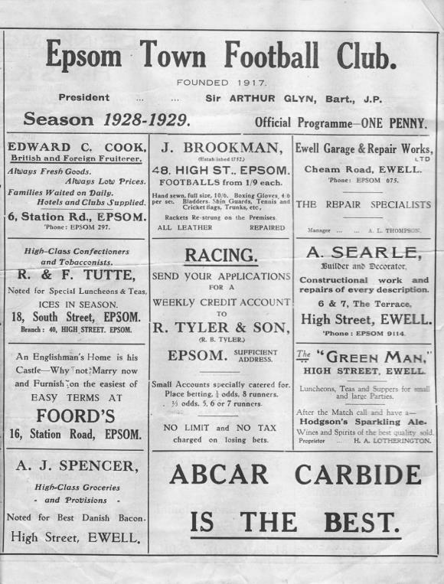
Of all dates in the calendar year, our best playing record
is on the 16th February with 11 wins from 15 matches!

90 years ago today The famous Isthmian League side Casuals visited West Street for a Surrey Senior Cup Quarter-Final (see programme left) and led at half time, but two second half goals from George Carmichael and another from Freddie Behn gave us a 3-1 win and a Semi-Final against another powerful Isthmian League side in Wimbledon whom we would ultimately beat too!

67 years ago today Bill Goddard scored five goals as we annihilated Maidenhead United 8-1 in a Corinthian League Memorial Shield Semi-Final at West Street, earning a Final at Eastbourne F.C. against Hounslow who would defeat us in front of 5,000 spectators.

62 years ago today the mighty Dulwich Hamlet became our second Isthmian League scalp in that year’s Surrey Senior Cup, having previously defeated Kingstonian 5-1, Dulwich were defeated 5-3 as we racked up our 100th goal of the season and we would be extremely unlucky to lose to a freak goal against Wimbledon in the Semi-Final.

45 years ago today we visited Worplesdon in a Surrey Senior League match and won 4-1 with Tommy Tuite scoring all four of them, including a very rare penalty. We would be runners-up in the League that year with big things to follow the following season.

31 years ago today we defeated Beckenham Town 5-1 in a London Senior Cup tie that was moved to West Street as floodlights were not in place at Eden Park Avenue. Brian Perkins scored a hat trick, while Andy Winyard and an own goal completed the scoring.

30 years ago this week we travelled to Egham Town’s Tempest Road, as it was then called to find a muddy pitch. The hosts didn’t want to play but we did and the referee Steve Coffin agreed. Now Mr Coffin was somewhat of a controversial individual and we had come across him the previous season so we were a bit more aware of him, while Egham clearly didn’t and we won 2-1 with two extremely soft penalty awards in our favour, converted by Clive Hadingham.

Centre page for results

Centre page for results

Match and Ball Sponsorships – 2018/19
Opponent | Date | Match Sponsor | Ball Sponsor
Chessington & Hook Utd | 21/08/18 | Club President - Stella Lamont
Beckenham Town (FAC) | 28/08/18 | Building Shop Ltd
Cove | 08/09/18 | EEFC Management Committee
Tooting Bec | 15/09/18 | Building Shop Ltd
Bagshot (LC) | 25/09/18
Sheerwater | 06/10/18 | Paul Merritt
Knaphill U23  (Surrey Premier Cup) | 23/10/18 | Jack Jarman
Frimley Green | 03/11/18 | Our Chairman’s Grandchildren – George, Joseph, Ezara and Inaya
Sandhurst Town (LD1C) | 06/11/18 | Richard Lambert
Kensington Borough | 17/11/18 | Jeff & Arnold Pye
Dorkinian (SPC) | 20/11/18
Dorking Wanderers Res | 27/11/18
Godalming Town | 01/12/18 | John Bonner
Bedfont & Feltham | 08/12/18
Eversley & California | 29/12/18
Ash United | 12/01/19 | Gary and Gemma Jarman
Bagshot | 19/01/19 | Steve and Geoff Dyke
Godalming Town (LC) | 12/02/19
British Airways | 16/02/19 | Pete Lumm
British Airways | 16/02/19 | Stephen Charnley
FC Deportivo Galicia | 12/03/19
Fleet Spurs | 06/04/19
Sandhurst Town | 20/04/19 | Club President - Stella Lamont
Farnham Town | 27/04/19 | In memory of Chris Henry R.I.P.
Match sponsorship costs just £60.00!

Sponsorship includes:

Admission, programmes and hospitality for three people.

A full page advert in the programme and mascot for the day (if required).

If you are interested, just speak to a Committee Member,
or drop me an email at: richard.c.lambert@gmail.com

Previous Managers
In our latest instalment we look at tougher times following relegation.

Ricky Kidd – Sept 1986 – March 1990
Adrian Hill – March 1990 – April 2003

The decision to appoint Ricky Kidd as Manager was a fairly easy one for our club. Despite no Managerial experience, he had a host of contacts and would surely be able to recover the poor start to the season that had principally led to the dismissal of Alan Webb.

Unfortunately for Kidd, that poor start would continue until mid-November and despite a storming end to the season, along with the emergence of a young defender by the name of Matt Elliott, we would just fall short.

Ricky was born in Merstham on 17th March 1953 and had an illustrious playing career at non-league level, principally with Dagenham and Sutton United and was an Installations Manager at Monotype works in Redhill; a company that would go on to provide a Combined Counties League club in the early part of the new Millennium. He had joined us as a player the previous October and would go on to make 120 appearances with 22 goals, including an appearance in goal in what would prove to be Elliott’s final match for the club; a 5-1 home win against Flackwell Heath on 2nd May 1988.

By then however, we had already suffered our second straight relegation, by a single point after being well adrift at the start of the season and were now back in the Isthmian League Division Two South. 1987/88 was also the year that the club sold the West Street ground, on the basis that we had struggled to meet interest payments while playing at the higher level against Sutton and Dulwich Hamlet, so were clearly unlikely to do it against the likes of Molesey and Dorking.

That season would end with a fifth place finish, but we never really troubled the top clubs and despite the partnership of Brian Perkins and a young Clive Hadingham which enabled us to reach the Fourth Round of the F.A. Vase, league performances were patchy and we finished 9th out of 21 in 1989/90. In 1989/90 performances dipped still further and the club advised him that his last match would be at Camberley on 10th March 1990; a game that finished goalless. His was only the third sacking of a Manager in our history, following Bill Kennedy and the aforementioned Webb.

Maybe Ricky had expressed concern about the amount of money available as we counted down the days before our ground departure, scheduled at that time for 1992, but whatever the reasons I personally feel that Ricky was just too nice to be a Manager and he actually continued playing for a while at Merstham before in later years joining Redhill as Manager and then South Park as Director of Football, where he currently remains, overseeing their rise from Steps Six to Four.

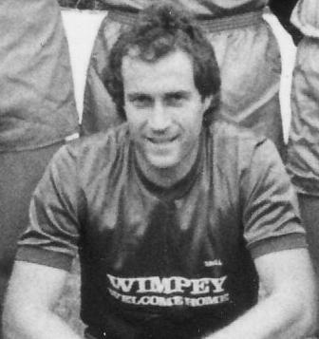
He was replaced by a familiar face. Adrian Hill had left us in 1985 for Croydon where he had taken much of the old Epsom squad with him, reaching a position of 4th in the Premier Division. However, success had not continued and as the squad broke up, Ada found himself out of a job, and had spells at Leatherhead too before returning to West Street. Kidd had brought in some good players, including Paul Mumford, Neil Robson and future Manager Lyndon Buckwell and Hill recognised this in his press comments when re-joining. He appealed for them all to stay, but inevitably a few departed. The team was very average by this time though and despite a stunning 5-0 win at Malden Vale with all the goals scored up the hill in the second half, we finished 14th.

Seasonal results didn’t really improve over the next few years but the club needed stability and

Ada had a job for life effectively. In 1992/93 we of course left West Street for Merland Rise and went out with a whimper, finishing 15th out of 20 and losing the last League match at West Street 2-1 at home to the Champions, the newly formed Aldershot Town. Fortunately we did have one final match at there when defeating Chipstead 1-0 on 6th May 1993 in the Semi-Final of the Southern Combination Cup (see team photo below).

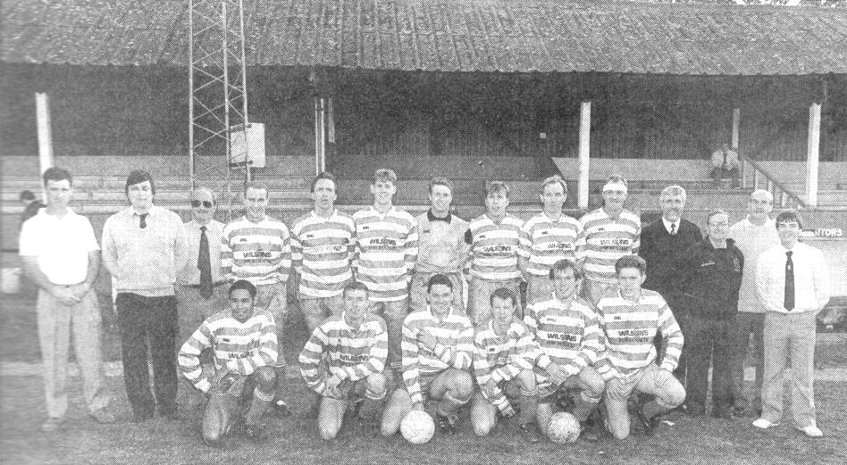
At Merland Rise matters were more difficult still, culminating in a 14th place finish out of just 17 clubs in 1996/97 in the by now renamed Isthmian League Division Three, but better times were around the corner for 1997/98 as we finished joint seventh along with Ware and also reached the Final of the Associate Members Trophy at Claremont Road, Hendon FC, after beating Bracknell Town, Marlow, Windsor & Eton and then Wealdstone, all four of which were in the higher Division Two. Alas Bedford Town had too much for us on the day and won 2-0 but it was our first Cup Final of any description for five years.

In 1998/99 Chris Desbrow and James Hall joined the club from nearby Croygas and were clearly very good, while up front, young Portugese striker Joao Tome scored 21 goals, supported by 16 from Kevin Webb, son of the former Manager, as we finished fifth, while in 1999/00 we were sixth and then seventh in 2000/01.

By this time, our team was beginning to take shape again. Youngsters like winger Barry Stevens had joined in August 1999 from landlords Banstead Athletic along with striker Simon Hatton and they scored the bulk of our goals over the next couple of seasons. Then in 2001 Simon Huckle and Joel Rogers joined the party and all four of them reached double figures as we gained a double promotion as a result of League reorganisation and our fifth placed finish earned us a move to the Isthmian League Division One South!

Not only that but we flew out of the blocks at the new higher level, winning our opening five matches, including a stunning 3-1 Bank Holiday Monday win at Worthing and led the table for a while. However, we suffered a 2-0 defeat in a nasty Monday night match at Colston Avenue which ended with two serious injuries and three players sent off. Their Manager Graham Roberts called us animals, which was the ultimate insult coming from him and this apparently had a bearing on Hill’s decision to retire at the end of 2002/03 with our team sitting very comfortably in ninth place. In fact, the expected replacements were doing so well, he bowed out early following the freak 1-5 home defeat to Worthing on 8th April 2003. Unfortunately a complete disaster would follow!

Player Sponsorship
Here is the latest list for 2018/19, with photos showing all of our players and Management that are available for sponsorship.

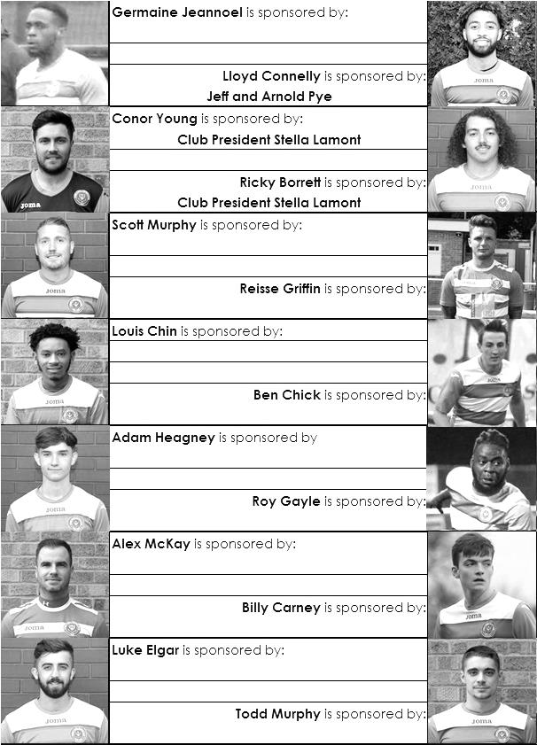

Sponsorship costs just £40 and it is easy to do. Just select a player who has not been previously sponsored and let a Committee Member know that you would like to sponsor them. Beware though. Until we have received the money it is possible for someone to jump in front of you, so don’t delay, sponsor today!

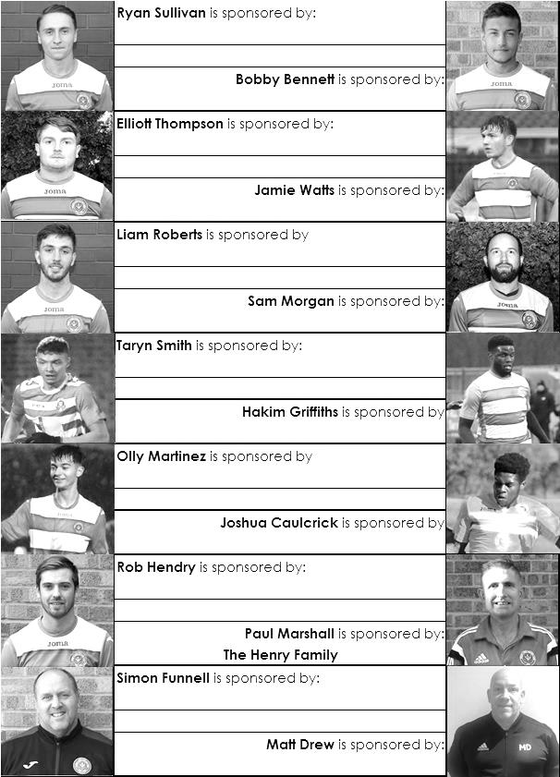

EL Records Premier Challenge Cup
Third Round
FC Deportivo Galicia | 0-2 | Sutton Common Rovers
AFC Hayes | 0-1 | Bedfont & Feltham
Epsom & Ewell | 5-1 | Godalming Town
Sheerwater | 0-3 | Banstead Athletic
Guildford City | 0-2 | CB Hounslow United
Spelthorne Sports | 0-1 | Hanworth Villa
Knaphill | 3-1 | Fleet Spurs
Chertsey Town | 1-2 | Abbey Rangers
Quarter Finals
Abbey Rangers | V | Epsom & Ewell
Knaphill | 19/2 | Bedfont & Feltham
Sutton Common Rovers | 18/3 | Hanworth Villa
CB Hounslow United | 19/2 | Banstead Athletic

Esoteric League Division One Challenge Cup
Second Round
Eversley & California | 2-3 | Bedfont & Feltham
Epsom & Ewell | 1-0 | Sandhurst Town
Tooting Bec | 4-1 | Ash United
Kensington Borough | 0-2 | FC Deportivo Galicia
Sheerwater | 2-3 | Chessington & Hook United
Fleet Spurs | 0-0 - 4-3p | Cove
Dorking Wanderers | 1-2 | Frimley Green
Godalming Town | 6-0 | Bagshot
Quarter-Finals
Tooting Bec | 5/3 | Frimley Green
Bedfont & Feltham | 1-2 | Epsom & Ewell
FC Deportivo Galicia | 5-1 | Godalming Town
Fleet Spurs | 0-0 – 4-3p | Chessington & Hook United

Surrey Premier Cup
Second Round
Ash United | 3-1 | Chessington & Hook United
Alfold | 0-1 | Nottsborough (holders)
Old Wilsonians | 1-6 | Lingfield
Sheerwater | 5-0 | Corinthian Casuals Reserves
Farnham Town | 4-1 | Westfield Reserves
Epsom & Ewell | 4-0 | Dorkinian
Met Police Reserves | 7-3 | Dorking Wanderers Reserves
Bagshot | 1-3 | Frimley Green
Quarter-Finals
Ash United | 1-3 | Frimley Green
Met Police Reserves | 20/2 | Epsom & Ewell
Farnham Town | 19/2 | Lingfield
Nottsborough (holders) | 16/2 | Sheerwater

British Airways – History
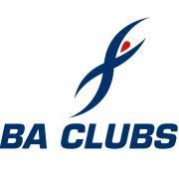
Very little if any early history of the BA football team can be found, except for an entry in the minutes of the initial minutes of the then Speedbird Club where the BA Football team was one of 6 other BA sections that were formed as part of the Sporting and Social Club for BOAC.

So it seems that the earliest date we can verify is April 1947 for the BOAC team, although no such evidence can be found for its counterpart BEA.

What we do know is that the BOAC & BEA teams have played in various local leagues since their inauguration in 1947. As part of a UK Aviation review UK airlines were integrated into one airline British Airways the United Kingdom's national airline, which was created in 1974 with the merger of the two largest UK airlines, British Overseas Airways Corporation (BOAC) and British European Airways (BEA), and including also two smaller regional airlines, Cambrian Airways and Northeast Airlines.

The merger was the completion of a consolidation process started in 1971 with the establishment of the British Airways Board, a body created by the British government to control the operations and finances of BOAC and BEA, which initially continued to exist as separate entities.

It took another 8 years before the teams amalgamated to become one all-encompassing British Airways Football Section, which was driven by the sale of the ‘old’ Silver Wing Club at Northolt to Ameretto’s Country Club and all sporting activities from Northolt moved to the Concorde Centre (formerly Speedbird Club) at Heston. The amalgamation of the two clubs created a huge football section with over 200 members. At that time there were approximately 15 adult teams comprising of BA Staff from office workers to pilots and from baggage handling to IT programmers.

The teams played in local leagues such as the Hanwell and District Midweek League (folded many years ago) this and was followed by the Airport League which has now also folded. The Saturday teams played in the West Middlesex League (that has now also folded) the teams moved to the London Commercial League. This League had ten divisions at one time with at least 10 teams in each division and all the teams had to have their own sports grounds! All this has gone now with companies selling off the land the private developers or deciding that they couldn’t afford to run sporting activities any longer, no wonder we are all getting fatter!

The Football teams at British Airways have had a very long, successful and proud history in Middlesex Junior football winning many league and county honours along the way. The BA Sat 1st team are probably one of the most successful teams in Middlesex Junior football having won the London Commercial League the Division 1 title and Senior League Cup on many occasions. The team has also been successful in the Middlesex County Intermediate Cup winning this cup eight times and in 2005/06/07 this trophy was won 3 years running a feat not equalled (so far)! We have also had success in the Middlesex County Premier Cup winning the trophy in 1997 against a very strong Hayes Reserves XI.

Since moving to the Middlesex County League in 2007 we have won the Premier Division twice and after finishing top of the Premier League we have now gained promotion to the Combined Counties League a big step up for our Club, we hope to justify our promotion with a good showing in our first year. We will also be playing at Bedfont and Feltham in our new ground share arrangement with Brian Barry and his team at the Orchard.

Combined Counties League – Division One
Saturday, 16th February 2019 - Kick-off 3.00 p.m.
Epsom and Ewell  (Royal Blue & White hoops) | V |  | British Airways  (All Yellow)
Squad | NUMBERS |  | Squad
Conor Young |  |  | Perry Cheadle
Louis Chin |  |  | Carl Adamson
Luke Elgar |  |  | Chris Baah
Reisse Griffin |  |  | Callum Bennett
Lloyd Connelly |  |  | Jake Girt
Jamie Watts |  |  | Jordan Haynes
Adam Heagney |  |  | Craig Jeff
Sam Morgan |  |  | Aaron Jones
Todd Murphy |  |  | Jeff Kalejaiya
Ryan Sullivan |  |  | Steve Richards
Liam Roberts |  |  | Michalis Liversey
© Scott Murphy |  |  | Jake Morten
Elliott Thompson |  |  | Lewis Nobes
Bobby Bennett |  |  | Ryan Nobes
Rob Hendry |  |  | Daniel Kusimo
Roy Gayle |  |  | Mustafa Khatoun
Olly Martinez |  |  | Harvey Pasma
Germaine Jeannoel |  |  | Charlie Rose
Hakim Griffiths |  |  | Callum Deverill
Ben Chick |  |  | Joe Iguchi
Billy Carney |  |  | Brad Scott
Simon Funnell | MANAGER |  | Jason Owens
Matt Drew / Paul Marshall | ASSISTED BY |  | Rob Pearce
Matt Drew | COACHES
Chantelle Farrell | PHYSIO
REFEREE: D.Sheldrake
ASSISTANTS: G.Smith, I.Hempel
We are fortunate to have today’s match sponsored twice!
by Steve Charnley
and by our former Chairman Pete Lumm

OUR NEXT VISITORS TO HIGH ROAD
FC Deportivo Galicia
Combined Counties League – Division One
Tuesday, 12th March 2019 – 7.45 pm

